Haroon Arshad

FA21-BEE-095

Output1:

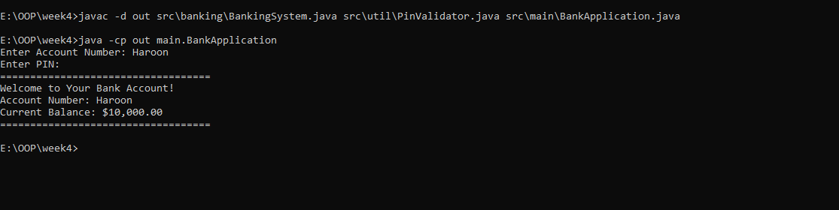

OUTPUT2:

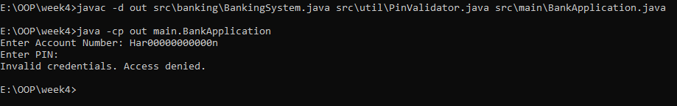

Output3:

